附件：高昌区历史遗留矿山基本情况表
序号 | 图斑编号 | 图斑小类 | 地理位置 | 图斑面积（m2） | 中心坐标 |  | 拐点坐标 | 图斑影像
 |  |  |  |  | 经度 | 纬度
1 | CT6504022017000025003 | 无法确认治理恢复责任主体的无主废弃矿山 | 二二一团北侧 | 121034.54 | 89.008402 | 42.991759 | 1,89.005991,42.991672  2,89.006283,42.991702  3,89.006430,42.991750  4,89.006452,42.991842  5,89.006454,42.991964  6,89.006517,42.991995  7,89.006805,42.992115  8,89.007003,42.992204  9,89.007277,42.992469  10,89.007275,42.992599  11,89.007242,42.992705  12,89.007230,42.992797  13,89.007228,42.992903  14,89.007321,42.992942  15,89.007466,42.992951  16,89.007591,42.992952  17,89.007803,42.992889  18,89.008024,42.992873  19,89.008094,42.992875  20,89.008283,42.992880  21,89.008625,42.992899  22,89.008853,42.992954  23,89.009068,42.993070  24,89.009185,42.993163  25,89.009222,42.993206  26,89.009402,42.993327  27,89.009482,42.993435  28,89.009548,42.993558  29,89.009684,42.993583  30,89.010171,42.993563  31,89.010405,42.993561  32,89.010714,42.993720  33,89.010915,42.993689  34,89.011104,42.993619  35,89.011151,42.993529  36,89.011236,42.993492  37,89.011359,42.993497  38,89.011457,42.993474  39,89.011714,42.993248  40,89.011859,42.993130  41,89.011932,42.992993  42,89.011974,42.992822  43,89.011999,42.992488  44,89.011997,42.992169  45,89.011956,42.991926  46,89.011928,42.991635  47,89.011851,42.991558  48,89.011780,42.991534  49,89.011728,42.991533  50,89.011598,42.991566  51,89.011434,42.991659  52,89.011211,42.991824  53,89.011080,42.991923  54,89.010942,42.991998  55,89.010714,42.991984  56,89.010507,42.992052  57,89.010383,42.992074  58,89.010247,42.992073  59,89.010150,42.992029  60,89.010072,42.991911  61,89.010039,42.991861  62,89.009986,42.991818  63,89.009907,42.991818  64,89.009783,42.991831  65,89.009692,42.991887  66,89.009671,42.991976  67,89.009657,42.992035  68,89.009623,42.992149  69,89.009517,42.992234  70,89.009408,42.992199  71,89.009293,42.992079  72,89.009243,42.991955  73,89.009244,42.991860  74,89.009369,42.991672  75,89.009377,42.991587  76,89.009428,42.991483  77,89.009470,42.991392  78,89.009528,42.991240  79,89.009537,42.991126  80,89.009537,42.991093  81,89.009491,42.991009  82,89.009470,42.990988  83,89.009318,42.990950  84,89.009308,42.990948  85,89.009175,42.990931  86,89.008980,42.990893  87,89.008908,42.990870  88,89.008740,42.990846  89,89.008693,42.990836  90,89.008508,42.990794  91,89.008276,42.990742  92,89.007790,42.990649  93,89.007469,42.990554  94,89.007252,42.990492  95,89.007233,42.990415  96,89.007320,42.990308  97,89.007371,42.990133  98,89.007349,42.989967  99,89.007241,42.989835  100,89.007015,42.989759  101,89.006672,42.989697  102,89.006397,42.989644  103,89.006016,42.989566  104,89.005906,42.989566  105,89.005585,42.989657  106,89.005380,42.989822  107,89.005189,42.990321  108,89.005113,42.990542  109,89.005117,42.990659  110,89.005124,42.990770  111,89.005134,42.990917  112,89.005271,42.991275  113,89.005312,42.991590  114,89.005433,42.991601  115,89.005649,42.991565  116,89.005799,42.991566  117,89.005940,42.991620  118,89.005991,42.991672 | 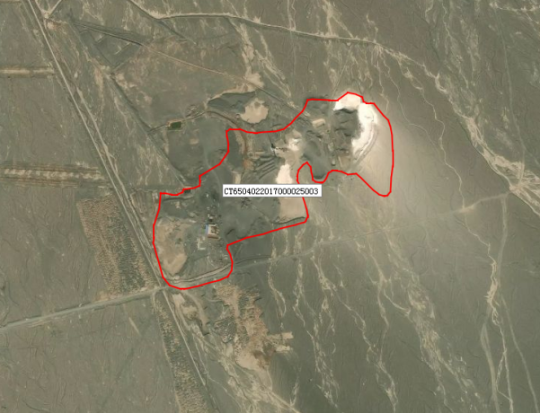
2 | ZJ6504022021002001 | 无法确认治理恢复责任主体的无主废弃矿山 | 312国道南侧、原种场道路东侧 | 594338.5 | 89.29416 | 42.929173 | 1,30441899.84,4755690.088  2,30442199.27,4755724.571  3,30442465.49,4755505.561  4,30442576.07,4755256.14  5,30442768.19,4755000.752  6,30442811.25,4754572.135  7,30442584.27,4754378.404  8,30442395.75,4754602.043  9,30442242.65,4754878.261  10,30442114.53,4754889.914  11,30441899.84,4755690.088 | 